**ARTIFICIAL INTELLIGENCE and MACHINE LEARNING**

Project Report

Semester-IV (Batch-2022)

LAPTOP PRICE PREDICTION

M



**Supervised By:**  **Submitted By:**

     Ms. Shagun Sharma                                                                Kunsh Bhandari 2210990529

Lakshay Goel 2210990535

Lakshay Suri 2210990537

Lakshita Chopra 2210990538

**Department of Computer Science and Engineering**

Chitkara University Institute of Engineering & Technology,

**Chitkara University, Punjab**

ABSTRACT

The ever-evolving landscape of the laptop market presents a constant challenge for consumers seeking to make informed purchase decisions. With a vast array of brands, specifications, and features to consider, accurately determining a laptop's fair market value can be a daunting task. This project directly addresses this issue by leveraging the power of Machine Learning (ML) to develop a robust price prediction model.

We achieve this by gathering a comprehensive dataset containing detailed specifications for various laptops alongside their corresponding market prices. By meticulously analyzing this data, the model learns to identify the key features, such as processor type, RAM size, storage capacity, display resolution, and graphics card capabilities, that significantly influence a laptop's overall performance and, consequently, its market price. This intricate relationship between specifications and price often proves challenging for consumers to grasp intuitively.

Traditionally, consumers have relied on methods like online reviews, comparison websites, and retailer recommendations for price estimation. While these can provide a general sense of value, they may not always be accurate or objective. This project presents a more reliable and data-driven approach. Through the power of ML, the model learns to recognize the complex interplay between specifications and translate it into a predicted price point for new laptops.

The significance of this project extends beyond empowering individual consumers. By providing a user-friendly tool for price prediction, it promotes greater price transparency within the laptop market. Consumers gain the confidence to negotiate effectively and identify potential discrepancies, while manufacturers and retailers can utilize the model's insights to analyze market trends and develop optimized pricing strategies. Ultimately, this project serves as a valuable bridge between complex technology and informed consumer decision-making, fostering a more transparent and efficient marketplace for laptops.

INDEX

1. Introduction

2. Problem Definition and Requirements

3. Proposed Design / Methodology

4. Results

5. References

INTRODUCTION

The ever-evolving landscape of technology demands informed decision-making, especially when it comes to purchasing complex electronics like laptops. With a plethora of brands, specifications, and features to consider, determining the fair market value of a laptop can be a daunting task for consumers. This project aims to bridge this gap by leveraging the power of Artificial Intelligence (AI) and Machine Learning (ML) to develop a robust price prediction model for laptops.

**Background**

The modern laptop market is highly competitive, with manufacturers constantly innovating and releasing new models with varying specifications. These specifications, such as processor type, RAM size, storage capacity, display resolution, and graphics card capabilities, significantly influence a laptop's overall performance and, consequently, its market price. However, keeping track of these intricate details and their correlation with price can be challenging for the average consumer.

Traditionally, consumers have relied on online reviews, comparison websites, and retailer recommendations to estimate laptop prices. While these methods can provide a general sense of value, they may not always be accurate or objective. In recent years, the field of Machine Learning has emerged as a powerful tool for tackling complex data analysis tasks like price prediction. By training ML models on large datasets containing laptop specifications and their corresponding market prices, it becomes possible to identify patterns and relationships between these factors.

**Objective**

This project's primary objective is to develop a Machine Learning model capable of predicting the price of a new laptop based on its key specifications. By analyzing historical data, the model will learn to recognize the influence of various specifications on the final price point.

Here are some specific objectives outlined for this project:

* **Data Collection and Preprocessing:** Gather a comprehensive dataset containing laptop specifications and their corresponding selling prices. Clean and prepare the data for efficient model training.
* **Feature Engineering:** Analyze the collected data and identify the most relevant features (specifications) that significantly impact laptop price. Perform necessary transformations on these features to enhance the model's performance.
* **Model Selection and Training:** Evaluate various Machine Learning models suitable for price prediction tasks. Train the chosen model(s) on the prepared dataset, optimizing its hyperparameters to achieve the best possible accuracy.
* **Model Evaluation:** Evaluate the trained model's performance using appropriate metrics like Mean Squared Error (MSE) or R-squared. Analyze the results to assess the model's effectiveness in predicting laptop prices.
* **Deployment (Optional):** Develop a user-friendly interface (web application or script) allowing users to input laptop specifications and obtain price predictions based on the trained model.

**Significance**

This project offers several significant advantages for consumers and the tech industry alike. Here are some key aspects highlighting its importance:

* **Informed Decision-Making:** Consumers can leverage the model's predictions to make more informed purchase decisions by obtaining a realistic estimate of a laptop's fair market value.
* **Price Transparency:** The model can help promote greater price transparency within the laptop market by highlighting potential discrepancies and providing a baseline for price comparison.
* **Streamlined Research:** Consumers can save valuable time and effort when researching laptops by using the model to quickly narrow down their options based on budget constraints.
* **Market Analysis:** The model can be used by manufacturers and retailers to analyze market trends and identify potential pricing strategies based on specific laptop configurations.

PROBLEM DEFINITION AND REQUIREMENT

**Problem Statement**

The modern laptop market boasts a wide range of options with varying specifications and features that directly impact their price points. Consumers often struggle to determine the fair market value of a laptop due to the complexity of specifications and the lack of a clear understanding of how these features influence price. Traditional methods like online reviews, comparison websites, and retailer recommendations can be subjective and lack accuracy. This project aims to bridge this gap by developing a Machine Learning (ML) model capable of predicting laptop prices based on their key specifications.

**Software Requirements**

* **Programming Language:** Python (due to its vast ecosystem of ML libraries)
* **Machine Learning Libraries:**
  + **Scikit-learn:** Provides a comprehensive set of tools for data manipulation, model selection, training, and evaluation.
  + **Pandas:** Offers data analysis and manipulation functionalities.
  + **NumPy:** Enables efficient numerical computations.
  + (Optional) TensorFlow or PyTorch: If deep learning models are explored for prediction.
* **Data Visualization Libraries:**
  + **Matplotlib or Seaborn:** Used to create informative charts and graphs for data exploration and model performance analysis.
* **Jupyter Notebook or PyCharm:** Interactive development environments for writing and running code, visualizing data, and documenting the project.

**Hardware Requirements**

* **Processing Power:** A computer with a mid-range processor (minimum i5 or equivalent) is sufficient for handling data processing and model training with smaller datasets. For larger datasets, a more powerful processor (i7 or equivalent) is recommended.
* **Memory (RAM):** Minimum 8GB RAM is recommended to handle data loading and model training efficiently.
* **Storage:** Sufficient storage space is needed to accommodate the dataset size, which may vary depending on the chosen source. For smaller publicly available datasets, 50GB might suffice. Large private datasets can require significantly more storage.

**Data Set Requirements**

* **Data Source:** A comprehensive dataset containing laptop specifications and their corresponding market prices is crucial.
  + Publicly available datasets can be found on platforms like Kaggle or UCI Machine Learning Repository.
  + Alternatively, web scraping techniques can be employed to collect data from online retailers. (Ensure compliance with website terms of service).
* **Data Format:** The dataset should be in a structured format like CSV (Comma-Separated Values) or Excel spreadsheets for easy manipulation with Python libraries.
* **Data Attributes:**
  + **Target Variable:** The laptop's market price (numerical value).
  + **Feature Variables:** Specifications influencing the price, such as:
    - Processor type (e.g., Intel Core i5, AMD Ryzen 7)
    - RAM size (e.g., 8GB, 16GB)
    - Storage capacity (e.g., 256GB SSD, 1TB HDD)
    - Display resolution (e.g., 1920x1080, 3840x2160)
    - Graphics card type (e.g., NVIDIA GeForce GTX 1650, integrated graphics)
    - Screen size (e.g., 13.3", 15.6")
    - Brand (optional)
    - Operating System (optional)
* **Data Quality:** Data should be cleaned and preprocessed to address missing values, inconsistencies, and outliers before model training.

**Additional Considerations**

* **Data Size:** The size of the dataset can impact the training time and model complexity. Start with a manageable dataset and explore techniques like data augmentation if needed.
* **Data Relevance:** The dataset should reflect the current market trends to ensure accurate price predictions. Regular updates might be necessary to maintain model effectiveness.
* **Model Selection:** Evaluate different Machine Learning algorithms (e.g., Linear Regression, Random Forest) on the chosen dataset to identify the one with the best prediction performance.

By carefully considering these requirements and addressing the challenges of data acquisition, quality, and relevance, you can build a robust Machine Learning model for predicting laptop prices, empowering consumers with valuable decision-making tools.

METHODOLOGY

**Data Collection:**

* Obtain a dataset containing information about various laptop models.
* Features include brand, RAM, processor, screen size, storage capacity etc.
* Kaggle can be used to provide such datasets.

**Data Exploration and Preprocessing:**

* Load the dataset using libraries like Pandas.
* Remove irrelevant columns (e.g. 'Unnamed: 0.1','Unnamed: 0', 'name').
* Check for missing values and handle them.
* Convert alphanumeric data (e.g. GPU, CPU etc.) into usable formats.

**Feature Engineering:**

* Extract relevant features from existing columns.
* For example:
  + Create a “ppi”(pixels per inches) feature based on the presence of display size and resolution dimensions.
  + Engineer features related to RAM and CPU.

**Exploratory Data Analysis (EDA):**

* Understand correlations and patterns using corr() function.
* Visualize relationships between features and target variable (price) using seaborn and matplotlib.

**Model Selection:**

* Linear Regression as it is simple and easily interpretable.
* SVR(Support Vector Regression) as it is a powerful regression technique.

**Model Training and Evaluation:**

* Split the dataset into training and testing sets.
* Train the chosen model on the training data.
* Evaluate model performance using regression evaluation metrics like R-squared, mean squared error etc.

RESULTS

Relationship between pixels per inches and price

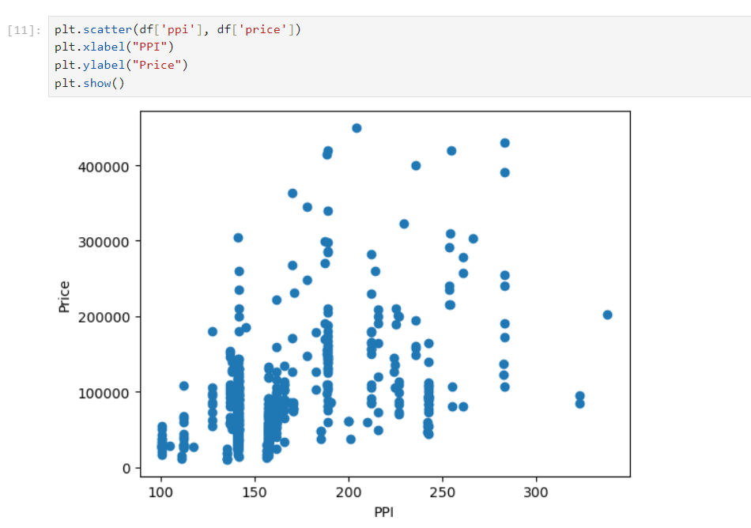

Relationship between RAM and price

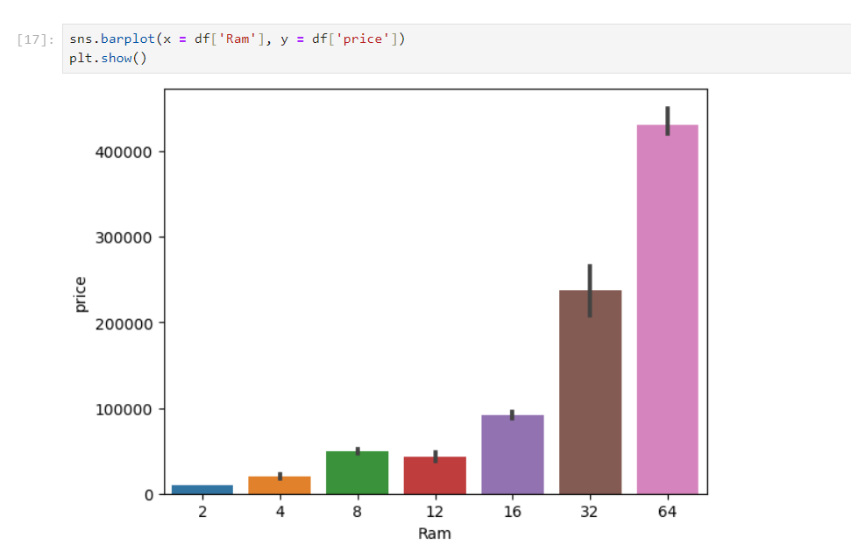

Relationship between ROM and price

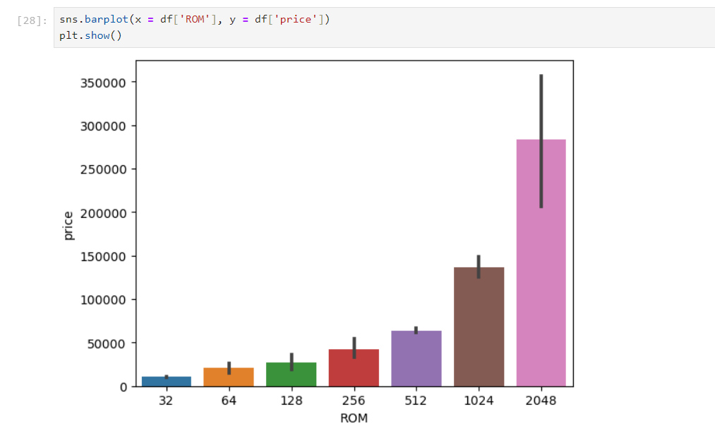

Relationship between processor and price

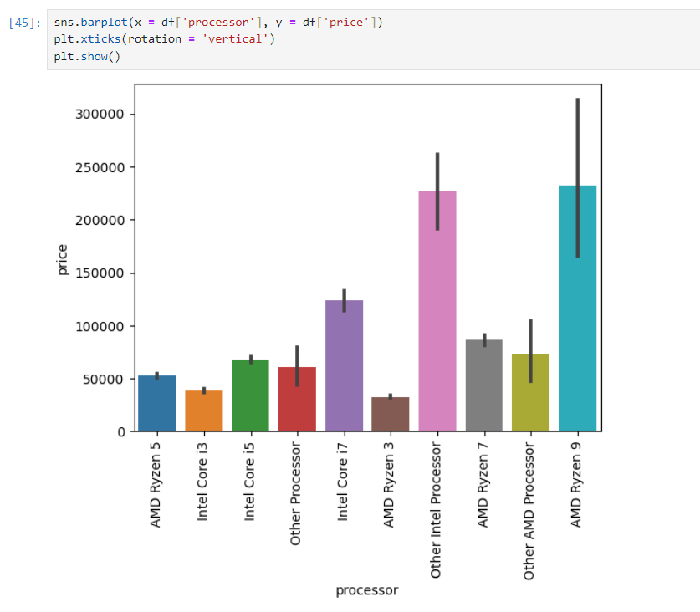

Relationship between CPU and price

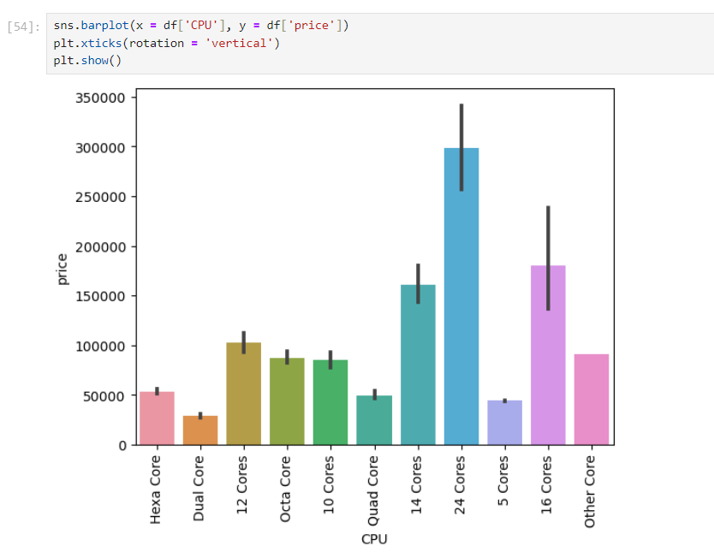

Relationship between RAM type and price

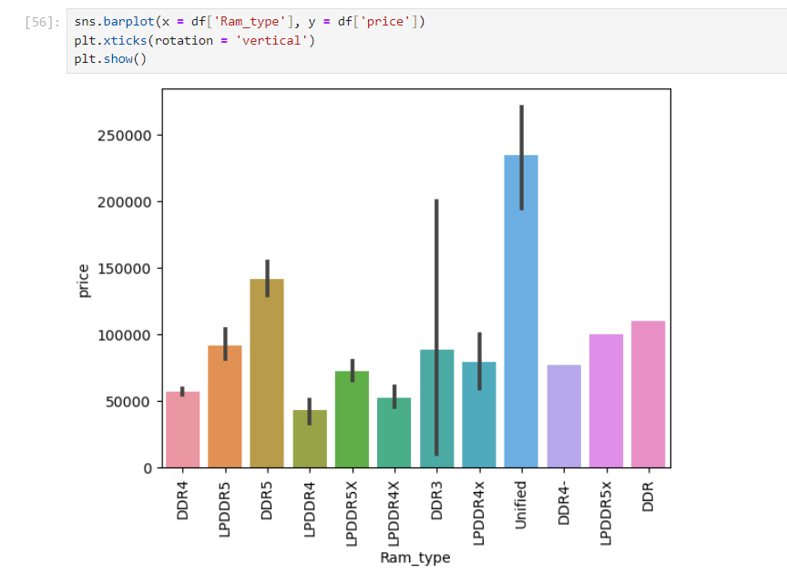

Relationship between OS type and price

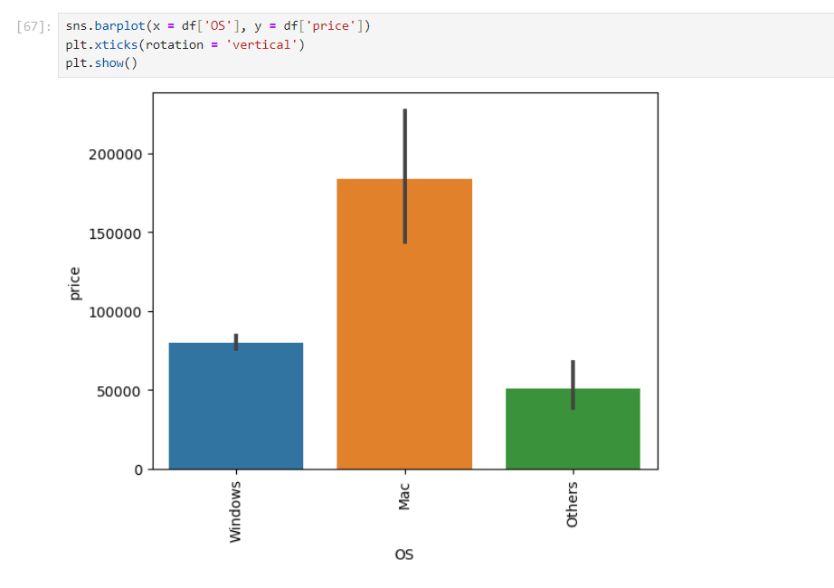

CONCLUSION

**The Model's Limitations and Considerations**

It's important to acknowledge the limitations of this project's initial iteration. While the Machine Learning model offers valuable insights, it is not a foolproof solution for determining an exact laptop price. Several factors can influence the final price point beyond the specifications analyzed:

* **Brand Reputation:** Brand recognition and consumer perception can impact pricing. A high-end laptop from a well-established brand might command a premium compared to a similar configuration from a lesser-known manufacturer.
* **Market Fluctuations:** Supply chain disruptions, component shortages, and seasonal trends can cause price fluctuations not necessarily captured by the model.
* **Retailer Pricing Strategies:** Discounts, promotions, and bundled offers offered by individual retailers can influence the final price consumers pay.

These factors highlight the importance of using the model's predictions in conjunction with other research methods when making a purchase decision. User reviews, brand comparisons, and checking for current market deals can provide a more holistic understanding of a laptop's true value.

**Broader Implications and Societal Impact**

The impact of this project extends beyond empowering individual consumers. The potential for this technology to be adopted by manufacturers and retailers creates a ripple effect across the industry:

* **Market Analysis and Product Development:** Manufacturers can leverage the model's insights to analyze price trends across different configurations. This data can be utilized to develop product lines that cater to specific price segments and consumer demands.
* **Inventory Management and Pricing Optimization:** Retailers can utilize the model to optimize their inventory management by predicting demand for specific laptop configurations based on price points. Additionally, the model can inform pricing strategies, allowing retailers to offer competitive prices while maintaining profitability.

Furthermore, the success of this project paves the way for similar applications in other consumer electronics sectors. By replicating this approach with smartphones, tablets, or other technology products, the concept of data-driven decision-making can empower consumers across the board.

**The Road Ahead: Continuous Learning and Refinement**

This project serves as a foundation upon which further development can build. Here are some key areas for ongoing advancements:

* **Data Augmentation and Expansion:** As the model encounters new data, its effectiveness can be enhanced. Techniques like data augmentation can be employed to artificially generate additional training data, further enriching the model's learning process.
* **Advanced Model Exploration:** While this initial project might have focused on simpler Machine Learning algorithms, venturing into deep learning techniques like Convolutional Neural Networks (CNNs) could potentially improve the model's accuracy. CNNs excel at handling complex relationships between data points, potentially leading to more nuanced price predictions.
* **Explainable AI Integration:** Implementing Explainable AI (XAI) techniques can provide valuable insights into the model's decision-making process. XAI tools can reveal the rationale behind the predicted price points, fostering trust and transparency for consumers who want to understand how the model arrives at its estimations.
* **User Interface and User Experience (UI/UX) Design:** Developing a user-friendly interface for the model's deployment is crucial for maximizing its impact. This interface should present input options for laptop specifications clearly and display the predicted price in an easily understandable format.

**Conclusion**

This project has taken a significant leap towards a more informed and transparent laptop market ecosystem. By harnessing the power of Machine Learning, we have created a tool that empowers consumers and offers valuable insights for stakeholders. As technology continues to evolve, ongoing advancements in data acquisition, model sophistication, and user-centric design can further enhance this project's capabilities. Ultimately, this project contributes to bridging the gap between complex technology and informed consumer decision-making, paving the way for a more efficient and empowering marketplace for laptops. The project serves as a stepping stone towards a future where technology empowers consumers and fosters a more transparent and informed market landscape for various consumer electronics products.